Power BI- My space

14 September 2024

01:27 PM

What is power BI?...

**Power BI** is a business analytics service provided by Microsoft that allows users to visualize data and share insights across an organization. It enables users to connect to a wide range of data sources, transform the data, create dashboards, and generate reports. Power BI is popular for its ease of use, integration with other Microsoft products (like Excel, Azure, and SQL Server), and its capabilities in data visualization and analytics.

It helps simplifying raw data into easily understandable format and enabling data-driven decision-making

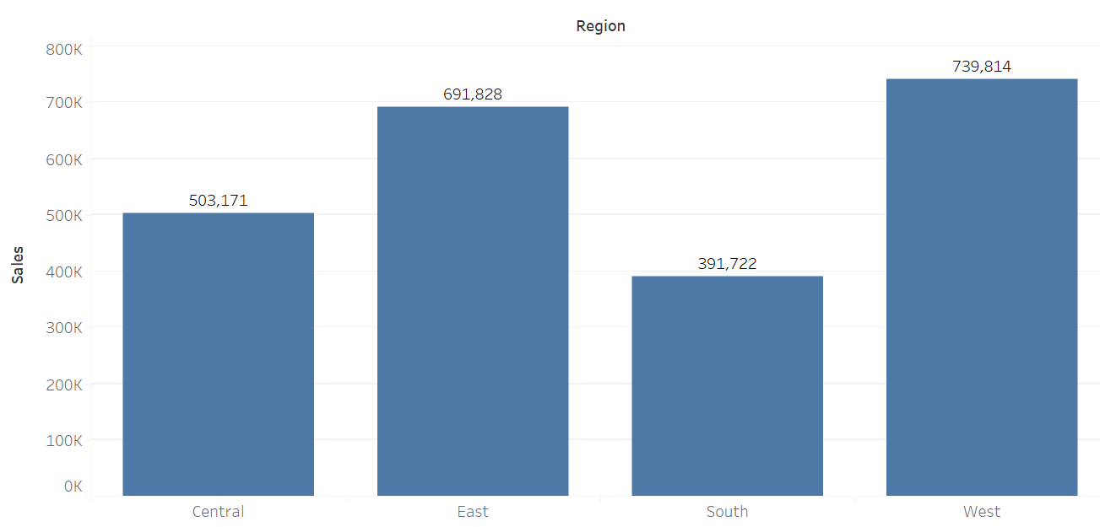

**Usage of Power BI:**

1. **Data Visualization**: Users can create rich visualizations, including charts, graphs, and maps, to represent data meaningfully.
2. **Data Connectivity**: Power BI connects to a variety of data sources, such as SQL databases, Excel, Azure, and cloud-based sources like Google Analytics, Salesforce, etc.
3. **Data Transformation**: With Power Query, users can clean, transform, and prepare data for analysis directly within Power BI.
4. **Dashboards and Reports**: Create interactive dashboards and reports to present insights and key performance indicators (KPIs).

**Installation of Power BI**

**Power BI Desktop** is only available for **Windows**. However, there are workarounds for **Mac users**:

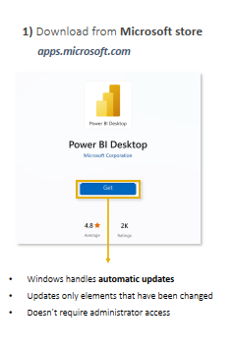

Settings

Open ==> File ==> Option and Settings and follow the below path

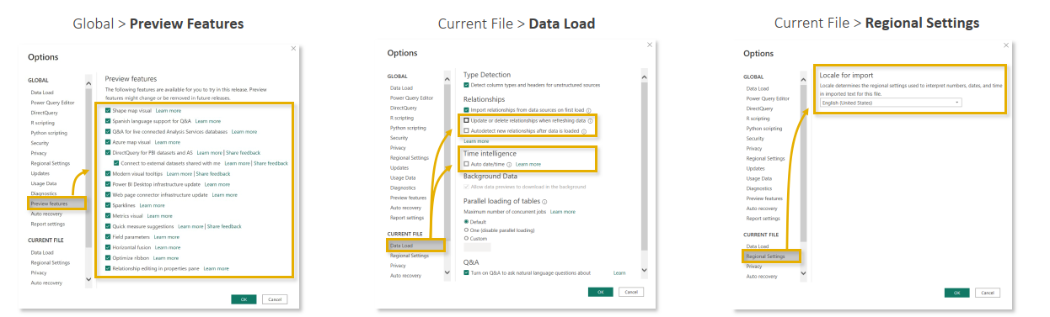

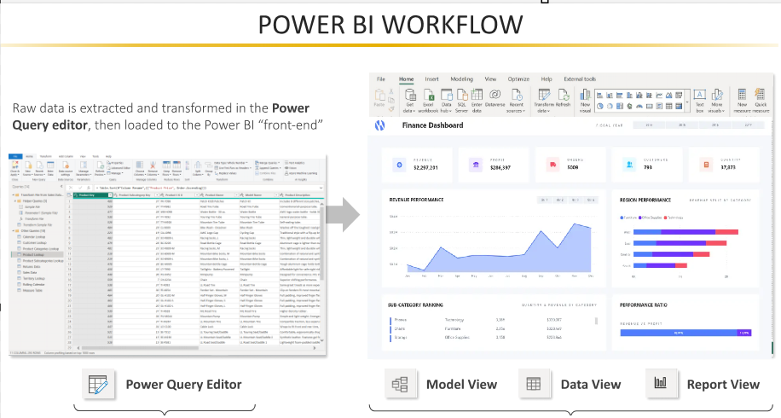

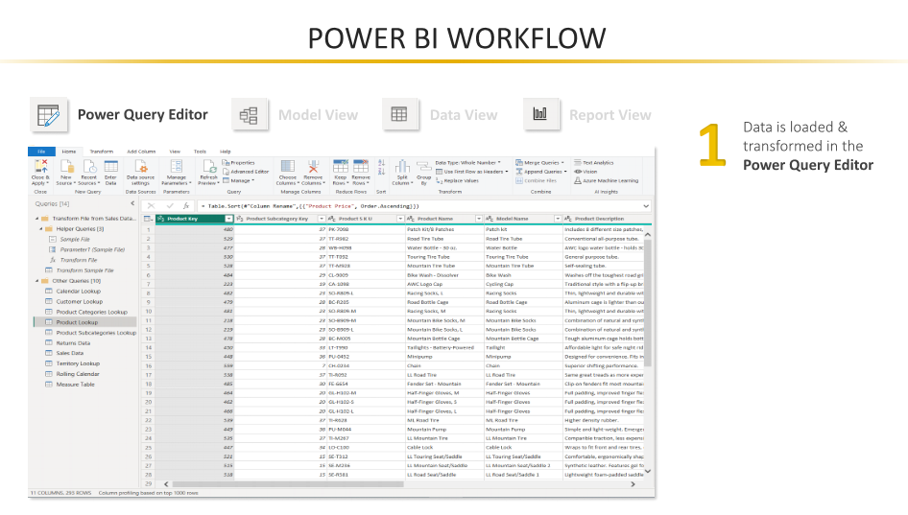

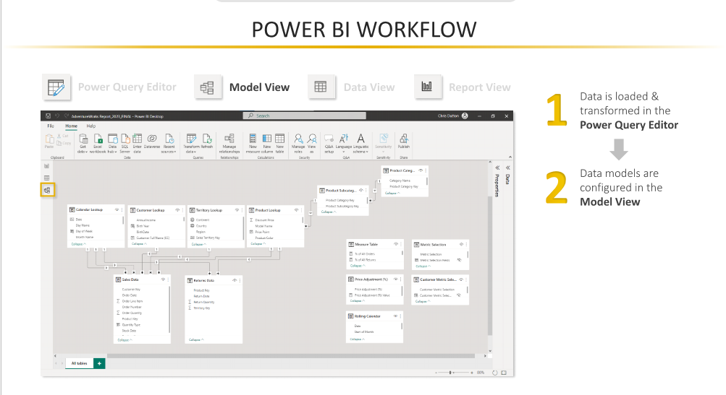

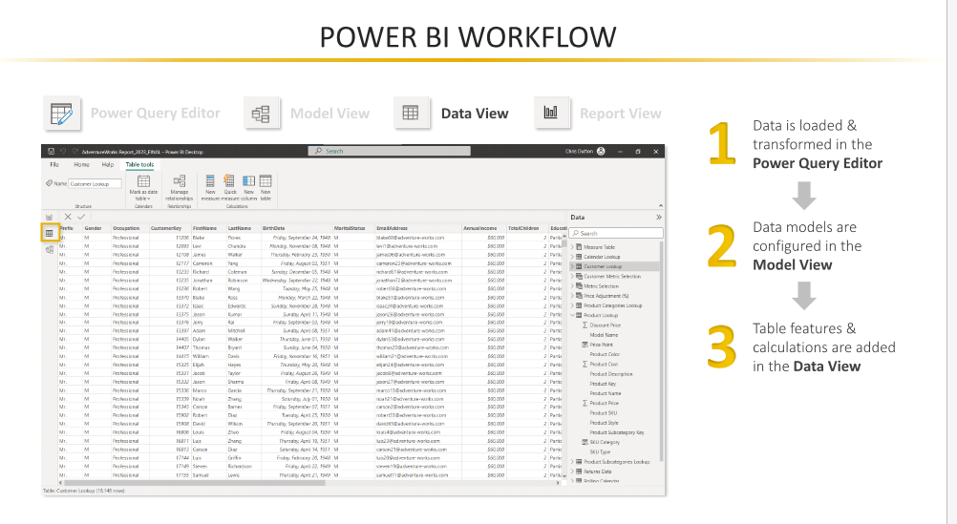

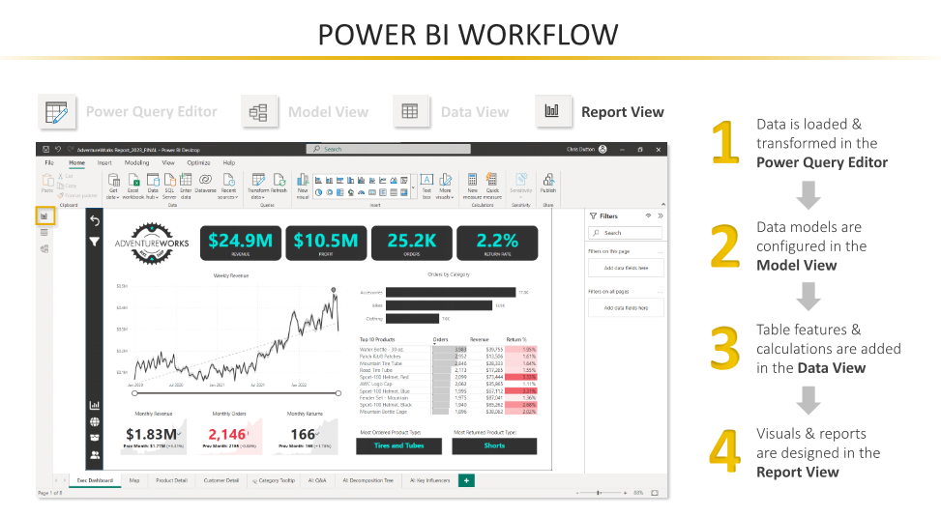

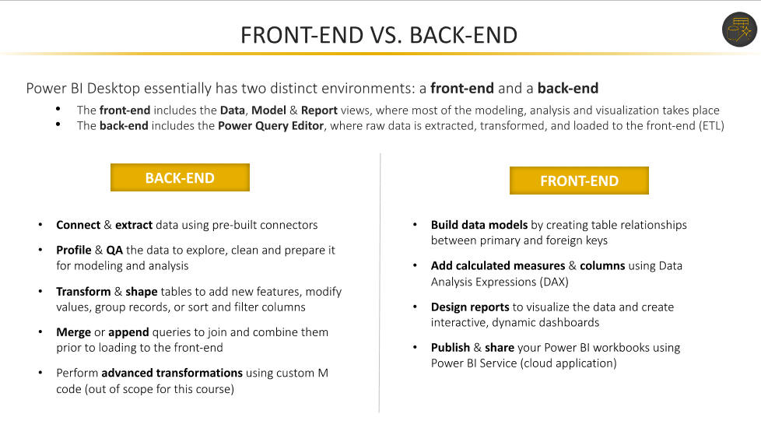

**How to connect Datasource, Eg excel and postgres**

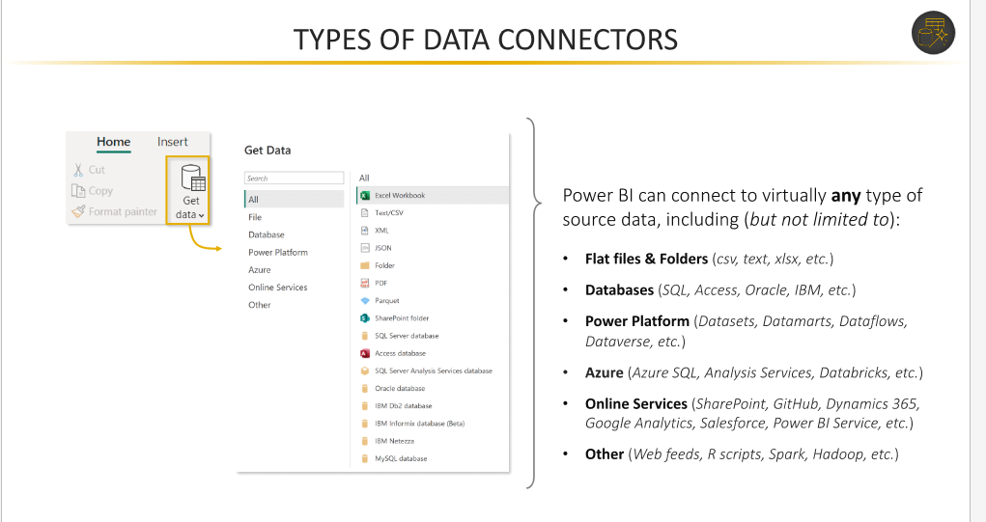

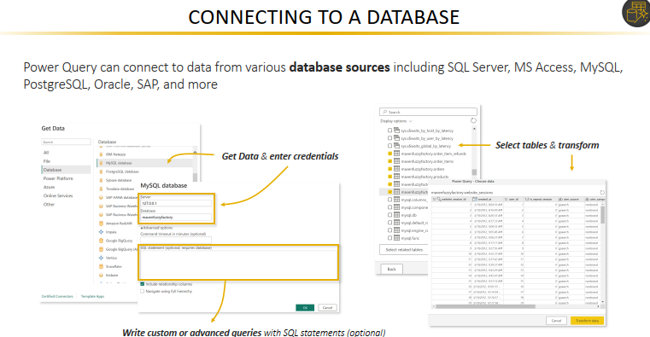

In Power BI, **Import** and **DirectQuery** are two primary modes of connecting and interacting with data sources. Each mode has its use cases, advantages, and limitations.

**1. Import Mode**

**Description:**

* Data from the source is **imported** into Power BI and stored in a highly optimized in-memory format using the **VertiPaq engine**.
* Reports and dashboards operate on this cached data.

**How it Works:**

* When you connect to a data source, Power BI retrieves the data and stores it in a .pbix file.
* Refreshes are required to update the data with the latest changes from the source.

**Advantages:**

* **Performance:** Queries run quickly because the data is already loaded into memory.
* **Offline Access:** Reports can work even when the source is offline, as the data is stored in Power BI.

**Limitations:**

* **Size Constraint:** Dataset size is limited to 1 GB for Pro users and up to 100 GB for Premium.
* **Refresh Needed:** Data is static until refreshed (manual or scheduled).

**Use Cases:**

* When working with small to medium-sized datasets.
* Scenarios requiring complex calculations and high performance.

**2. DirectQuery Mode**

**Description:**

* Data remains in the source system, and Power BI queries it **live** whenever a visualization is rendered or a report is interacted with.
* No data is imported or stored in Power BI.

**How it Works:**

* Power BI sends SQL queries directly to the data source for every interaction in the report.

**Advantages:**

* **Real-Time Data:** Displays the most up-to-date information without needing manual refreshes.
* **Large Data Sources:** Suitable for large datasets that cannot fit in memory.

**Limitations:**

* **Performance:** Query response time depends on the source system's speed and the complexity of the queries.
* **Dependency on Source:** Reports rely on the availability and performance of the data source.

**Use Cases:**

* When working with very large datasets that exceed Power BI's storage capacity.
* Scenarios requiring real-time or near real-time data updates.

* **Per Dataset (Import Mode):**
  + **Pro License:** Maximum dataset size is **1 GB** after publishing.
  + **Premium License (P1 and above):** Dataset size can go up to **100 GB** depending on the capacity SKU.
  + **Premium Per User (PPU):** Maximum dataset size is **100 GB**.

**How to save a file**

1. **Pbix - packaged workbook save along with data**
2. **Pbit - template only saved, data will not be saved**

In Power BI, **PBIX** and **PBIT** are two types of file formats that are used for different purposes:

1. **PBIX (Power BI Desktop File)**:
   * **This is the default file format used by Power BI Desktop to save reports.**
   * **A PBIX file contains the report's data model, visualizations, queries, connections to data sources, and all the report elements.**
   * **You can open, edit, and refresh the data in a PBIX file using Power BI Desktop.**
   * **PBIX files are essentially working files that hold all the logic and visual components of a report.**
2. **PBIT (Power BI Template File)**:
   * **This is a template file created from a PBIX file.**
   * **PBIT files contain the structure of the report (including visuals, layout, and queries) but exclude the actual data.**
   * **These are useful when you want to share the structure of a report (like a reusable template) without including sensitive data.**
   * **Users who receive a PBIT file can connect it to their own data sources and use it as a starting point for building reports.**